

**IOT Based Traffic Management System**

# **1.INTRODUCTION**

#### **A smart traffic management system utilizing camera data, communication and automated algorithms is to be developed to keep traffic flowing more smoothly. The aim is to optimally control the duration of green or red light for a specific traffic light at an intersection.**

#### **The traffic signals should not flash the same stretch of green or red all the time, but should depend on the number of vehicles present. When traffic is heavy in one direction, the green lights should stay on longer; less traffic should mean the red lights should be on for a longer time interval.**

#### **This solution is expected to eliminate inefficiencies at intersections and minimize the cost of commuting and pollution.**

# **II. LTERATURE SURVEY**

**The Internet of Things (IoT), also sometimes referred to as the Internet of Everything (hardware. These devices, often called ”connected” or ”smart” devices, can sometimes talk to other related devices, a process called machine-to-machine(M2M) communication, and acThe Internet of Things (IoT), also sometimes referred to as the Internet of Everything (IoE), consists of all the web-enabled devices that collect, send and act on data they acquire from their surrounding environments using embedded sensors, processors and communication hardware. These devices, often called ”connected” or ”smart” devices, can sometimes talk to other related devices, a process called** machine-to-machine(M2M) communication, and act on the information they

#### get **The existing traffic system is generally controlled by the traffic police. The main drawback of this system controlled by the traffic police is that the system is not smart enough to deal with the traffic congestion.**

#### **The traffic police official can either block a road for more time or let the vehicles on another road pass by i.e. the decision making may not be smart enough and it entirely depends on the official’s decision. Moreover, even if traffic lights are used, the time interval for which the vehicles will be shown a green or red signal is fixed.**

### **Therefore, it may not be able to solve the problem of traffic congestion. In India, it has been seen that even after the presence of traffic lights, traffic police officials are on duty, which means that in this system more manpower is required and it is not economical in nature.**from one another. **Humans can interact with the gadgets to set them up, give them instructions or access the data, but the devices do most of the work on their own without human intervention. Their existence has been made possible by all the tiny mobile components that are available these days, as well as the always-online nature of our home and business networks. Connected devices also generate massive amounts of Internet traffic, including loads of data that can be used to make the devices useful, but can also be mined for other purposes. All this new data, and the Internet-accessible nature of the devices, raises both privacy and security concerns. But this technology allows for a level of real-time information that we have never had before.**

### **We can monitor our homes and families remotely to keep them safe. Businesses can improve processes to increase productivity and reduce material waste and unforeseen downtime. Sensors in city infrastructure can help reduce road congestion and warn us when infrastructure is in danger of crumbling. Gadgets out in the open can monitor for changing environmental conditions and warn us of impending disasters.**

# **SYSTEM ANALYSIS:**

**A. EXISTING SYSTEM:**

#### **The camera transmits the data at specified time intervals to the processor (raspberry pi), it processes the data and sends the processed data to the controller. The computed data from Raspberry pi is then transmitted to the controller through Wi-Fi connectivity. The controller makes use of the collected data to perform the Intelligent Traffic routing.**

#### **In this system, the primary aim is to gather the information of moving vehicles and provide them a clear path till their destinations and traffic signals should switch automatically to give a clear way for these vehicles.**

#### **In this proposed system, the traffic lights are LEDs and the cameras. Both blocks are connected to a raspberry Pi using physical wires. The Node MCU is the traffic light controller which receives the collected camera data and manages the traffic lights by switching between green, yellow and red. The raspberry pi computes the number of vehicles in the street of the intersection it is monitoring based on the distances measured by the camera and the timing between those measurements. The raspberry pi thensends the number of cars every minute to the database.**

#### **The database is used to train the module in order to better predict the changes in timings of the traffic light and its density. This communication is done using Wi-Fi. More specifically, the cloud server uses an equation that takes the data received (number of cars) as input then determines the time interval of LED’s needed for a smooth traffic flow. This calculated time is then compared to the current actual time of the LEDs (this data is saved in a database).**

#### **The processor then comes up with a decision. If the current actual green time is less than the calculated time, the decision is to increase the green time, else to decrease the green time.**

# **IV. SYSTEM DESIGN**

## **The Architecture system consists of six modules:**

## **Raspberry Pi**

## **LED lights which are used for the purpose of signaling.**

## **Traffic cameras which are used for monitoring traffic.**

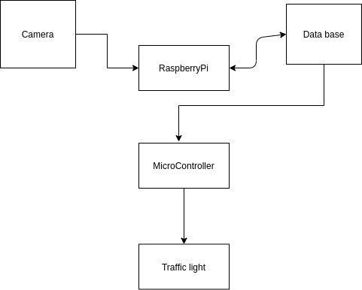

# **FLOW CHART**

**VI. CONCLUSION**

#### **Smart Traffic Management System has been developed by using multiple features of hardware components in IoT. Traffic optimization is achieved using IoT platform for efficient utilizing allocating varying time to all traffic signal according to available vehicles count in road path.**



